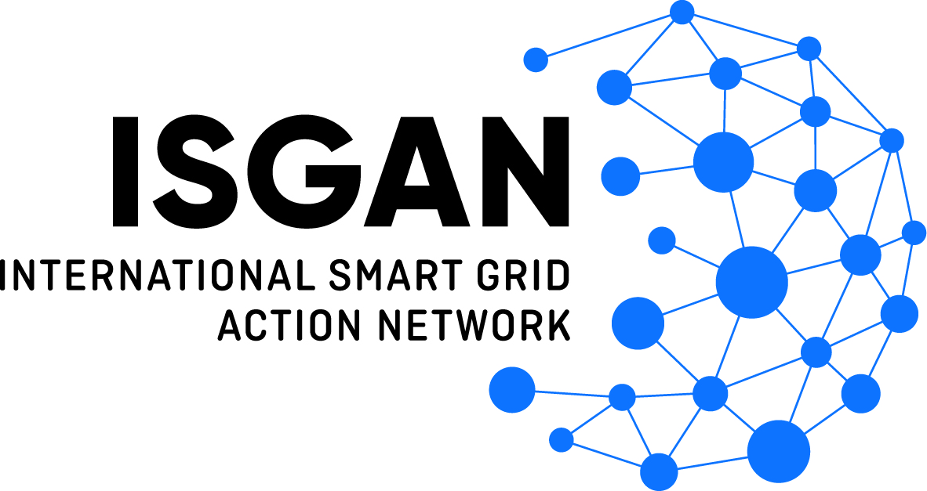

International Smart Grid Action Network
Organized as the Implementing Agreement for a
Co-operative Programme on Smart Grids (ISGAN)

Submission: Supplemental Information

Award of Excellence
2021

In partnership with the

PROJECT SUBMISSION TITLE
Information provided below should be consistent with the information provided in the
“Official Project Submission Form.”
Title:
Project Title
Location:
City Province/Region/State Country
Time Period:
Date(s) of Project
Primary Contact:
Name E-mail Address
SUPPLEMENTAL INFORMATION OVERVIEW
To support the claims and assertions in the Official Project Submission Form, Applicants may optionally include attachments, such as promotional materials, Power Point presentations, official documents, URL links to relevant websites, such as project websites and news articles, and/or written supplemental information (i.e., additional project narrative). If such attachments, links and/or written supplemental information are included, Applicants should complete the applicable sections of this Submission: Supplemental Information form.

Attachments and linked information, such as URL sites, can be in a language other than English, although a brief summary of that material in English is required for it to be considered. English must be used for provision of written information in this Supplemental Information form.
The Administrator and/or the Jury may, at their discretion, utilize the Administrator and/or its agents to contact the Submitting Entity (via its designated POC) to clarify information or to obtain additional information as needed for the Jury to make a reasoned judgment on the strength of the project measured against the Evaluation Criteria identified in the Official Rules. This might include a teleconference call or similar interaction to validate information and claims included in the Submission.
ADDITIONAL PROJECT NARRATIVE (optional)
- Background (As needed, describe the history/past that affected the design and implementation of the project. See Official Rules for details. )
[Please keep description to no more than 1 page using single-spaced, 12-pt font]

ADDITIONAL PROJECT NARRATIVE (optional)
- Purpose (Describe the key outcomes desired for the project. See Official Rules for details.)
[Please keep description to no more than one page using single-spaced, 12-pt font]

ADDITIONAL PROJECT NARRATIVE (optional)
- Approach (Describe the approach to planning and implementing the project, including the activities and evaluation metrics that determined the success and potential impact of the project. See Official Rules for details.)
[Please keep description to no more than one page using single-spaced, 12-pt font]

EVALUATION CRITERIA LOOK-UP
(required if attachments, URL links, and/or written supplemental information
are included in the Submission)
Specify where each Evaluation Criteria is addressed in your Submission, including this form, attachments, and other supplemental information provided.
[Please list the page numbers, section names, attachment names, URL link, or other identifying information below]

Evaluation Criteria | Related pages, sections, etc. in the Submission
Potential impact | Examples: Pages 4, 5 and 7 | Under “Approach” |  At www.example.net | Etc.
Economic rationale
Potential for replication or adaptation
Innovation
Other benefits

ATTACHMENTS AND URL LINKS
(required if attachments or URL links are included in the Submission)

Please list all Attachments and URL links here. Please ensure that all attachments and URL links provided in evidence of claims are also clearly referenced in your responses on the Official Project Submission Form and, if applicable, the Additional Project Narrative in this form. For any attachments or linked websites that are not in English, please provide a brief summary of their contents in English.

