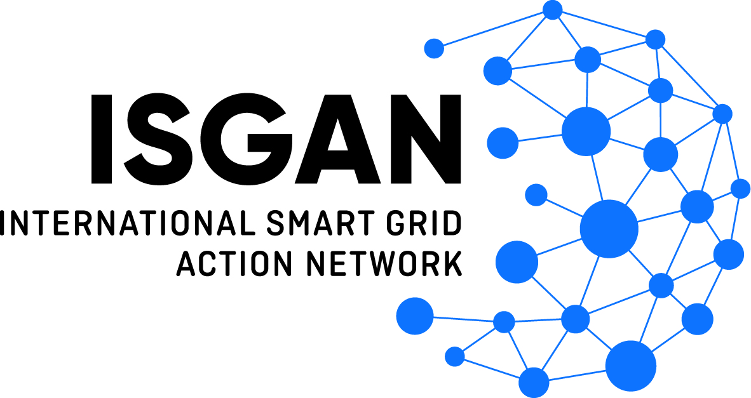

International Smart Grid Action Network
Organized as the Implementing Agreement for a
Co-operative Programme on Smart Grids (ISGAN)

Official Project Submission Form

Award of Excellence
2023

in partnership with

PROJECT SUBMISSION
Please read the entire application before beginning to complete this form. Please confine responses to the space allowed. If additional space is needed to provide further explanation, evidence of claims, references, and/or attachments, please use the Supplemental Information Form.
Forms should be submitted by electronic mail to: isgan-awards@smartgrid.or.kr. The Official Rules and other information related to the ISGAN Award of Excellence competition can be found online at http://www.iea-isgan.org/award2023.
Title:
Project Title
Location:
City Province/Region/State Country
Time Period of Project:
Date(s) of Project
Link to Project Website:
URL (if applicable)
Brief Project Description (Briefly describe the project, such as its principal objectives, scope, and key outcomes, and how the project relates to the theme, “Excellence in Artificial Intelligence for Smart Grid." See the Official Rules for details).
[Please confine the description to the text box, which would be approximately 250 words or less]

Project Background and Implementation (Describe the project background and implementation. Identify the purpose, approach, and project. Briefly describe how the project aligns with the ISGAN mission to “to accelerate progress on key aspects of smart grid policy, technology, and related standards.” See the Official Rules for details.)
[Please confine response to text box.]

Project Outcomes (Describe the project outcomes, and how the project attributes and outcomes exhibit excellence when measured against each evaluation criteria:
(1) Potential impact [25 points]; (2) Economic rationale [25 points]; (3) Potential for replication or adaptation [25 points]; (4) Innovation [15 points]; and (5) Other benefits [10 points]. See the Official Rules for details.)
[Please confine response to text box, adding as Attachments any relevant charts or graphs displaying performance indicators or metrics in evidence of claims.]

APPLICANT INFORMATION
Organization:
Business Name
Contact:
Last Name First Name M.I.
Position:
Position title
Location:
Street Address

City Province/Region/State Country
Phone:
Office Mobile Fax
E-mail:
Primary
Website:
Organization or project URL
Submit project nominations by e-mail to: isgan-awards@smartgrid.or.kr
See www.iea-isgan.org/award2023 for Official Rules.
ACCEPTANCE OF PROVISIONS (Signature needed)
All applications must include the signed statement below OR be accompanied by a signed cover letter acknowledging consent to the submission of the project and agreement to all the provisions of the Official Rules of the 2023 ISGAN Award of Excellence. Please check one of the following:
We will be including a signed letter as part of this application, acknowledging that we have read and agree to all the provisions of the Official Rules of the 2023 ISGAN Award of Excellence.
We have included a signature to the statement below.
I hereby consent to the submission of this project for consideration of the ISGAN Award of Excellence and acknowledge that by signing this cover sheet, I agree to all the provisions of the Official Rules of the 2023 ISGAN Award of Excellence, including the expectation that if the submitted project is selected as a winner, I agree to that representatives of the applying organization and heads of the project shall attend the awards ceremony to be held at the 14th Clean Energy Ministerial (CEM14) in July 2023.

Signature
Signature Date
Printed Name:
Name of Undersigned Position of Undersigned

PARTNER INFORMATION (if applicable)
If the proposed project involves partner entities, please list the name(s) of entities, associated organizational URL, and contact information (e.g., mailing address, phone, and e-mail address) for the representative point of contact for each partner. A letter delegating their representation to the Submitting Entity or the signed form below (Acceptance of Provisions by Partners) should accompany the application (two copies of the form are provided, duplicate and attach more if necessary). The inclusion of the letter or signed form signifies acceptance of all provisions in the Official Rules of the 2023 ISGAN Award of Excellence.
List organization and contact information for all partner entities below.
Partner Organization #1:
Organization Name and URL
Contact Name:
Name
Contact Information:
Phone E-mail Address
Partner Organization #2:
Organization Name and URL
Contact Name:
Name
Contact Information:
Phone E-mail Address
Partner Organization #3:
Organization Name and URL
Contact Name:
Name
Contact Information:
Phone E-mail Address
Partner Organization #4:
Organization Name and URL
Contact Name:
Name
Contact Information:
Phone E-mail Address
ACCEPTANCE OF PROVISIONS BY PARTNERS (if applicable)
If the proposed project involves one or more partner entities, one representative from each partner entity must either sign the statement below, consenting to the project submission and delegating their representation in this application to the submitting entity. Alternatively, the application must be accompanied by a signed letter from a representative of each partner entity acknowledging consent to the submission of the project, delegation of authority to submitting entity, and agreement to all the provisions of the Official Rules of the 2023 ISGAN Award of Excellence. Please check one of the following:
A signed letter from the partner entity (ies) will be included as part of this application.
A representative from each partner entity has signed the statement below.
I hereby consent to the submission of this project for consideration of the ISGAN Award of Excellence and delegate our representation in this application process to the Submitting Entity. I also acknowledge that by signing this cover sheet, I accept all the provisions of the Official Rules of the 2023 ISGAN Award of Excellence.

Partner Organization (#1):
Organization Name

Signature Signature Date
Printed Name:
Name of Undersigned Position of Undersigned
Location:
City/Region/Country
Contact Information:
E-mail Address Phone Number

Partner Organization (#2):
Organization Name

Signature Signature Date
Printed Name:
Name of Undersigned Position of Undersigned
Location:
City/Region/Country
Contact Information:
E-mail Address Phone Number

